IDE assist u. Tell u what functions r available, call libraries, tell u when put smth incorrectly.

String:

print(“Hello world!”)

Ways to comment:

Data types intro:

Numbers – int (whole numbers), floating point numbers (decimal numbers)

Strings – “anything involving chars or text”

Boolean – true or false

Numbers and math operators:

String basics:

Index = position of char in string from 0

Len = returns total chars in string

Boolean & equality operators:

Anything other than 0 is considered true in python – truthy or falsey

Variables intro:

Where u store data types and objects

Way of organising data within code. Names of variables v important

Cannot start with literals or use spacing and can change. Override when u write under it.

Concatenation & escape characters:

Add 2 blocks together using +

Can cast integer into a string:

\ \ is escape:



Control flow exercises:

Indentation allows python to distinguish when block starts and ends

Elif is short for “else if” and is used when the first if statement isn’t true, but you want to check for another condition

Can use or & and – or = one side needs to be true to execute statement, and = both need to be true to execute

Collections intro

Allow u to store large amounts of data in a particular format. We r focussing on lists and dictionaries.

Lists are index spaced.

Lists:

Just bc u can store multiple data types in a list does not mean u should. Useful for single data types.

.Append adds an item to the end of a list

Can remove items using .pop

.index searches for specific object in ur list

Dictionaries:

Key value pairs.

Use {}

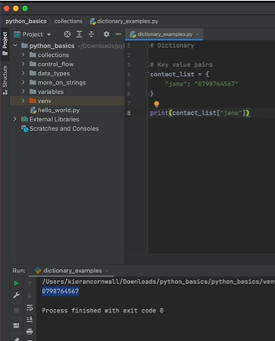

Advised to stick to strings as keys and to use caps or dashes rather than spaces for easier user readability.

Does not have method such as .append to add data. Must use another key value to add:

Methods u can use:

.keys returns all keys which is useful for large dictionaries

.values returns all values in dict

.pop removes particular entry and requires a key

Allows u to manage complex datasets:

Loops intro:

While loops:

Relies on Boolean to manage its state

Need to control so that it is not infinitely printing.

Can combine if/else

For loops:

Dependent on iterables – checking every item in that object

What types are objects in python are iterable? Consider do they hold more than 1 data type.

Store multi data values. Strings are iterables.

Dictionary and loop:

Functions intro:

Don’t repeat yourself.

Add argument:

At the moment, this particular function simply does smth. You give it 2 arguments and it prints. Not normally how u use functions. Some functions merely return smth to be used by another function or another part of ur programme. Going to break our functions into 2 separate functions. One called firstname, one called fullname:

